[E141] ARM panel

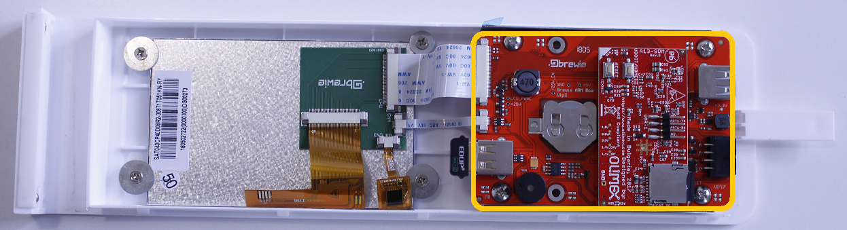

The ARM panel is located in the front panel assembly.

Check [E119] about how to remove the front panel from the B+.

To remove and replace the ARM module it is necessary to

* Remove the battery (Check [E145])
* Remove the the Olimex panel (Check [E142])
* Remove WIFI stick (Check [E143])
* Disconnect the marked cables of the display and unscrew the indicated screws

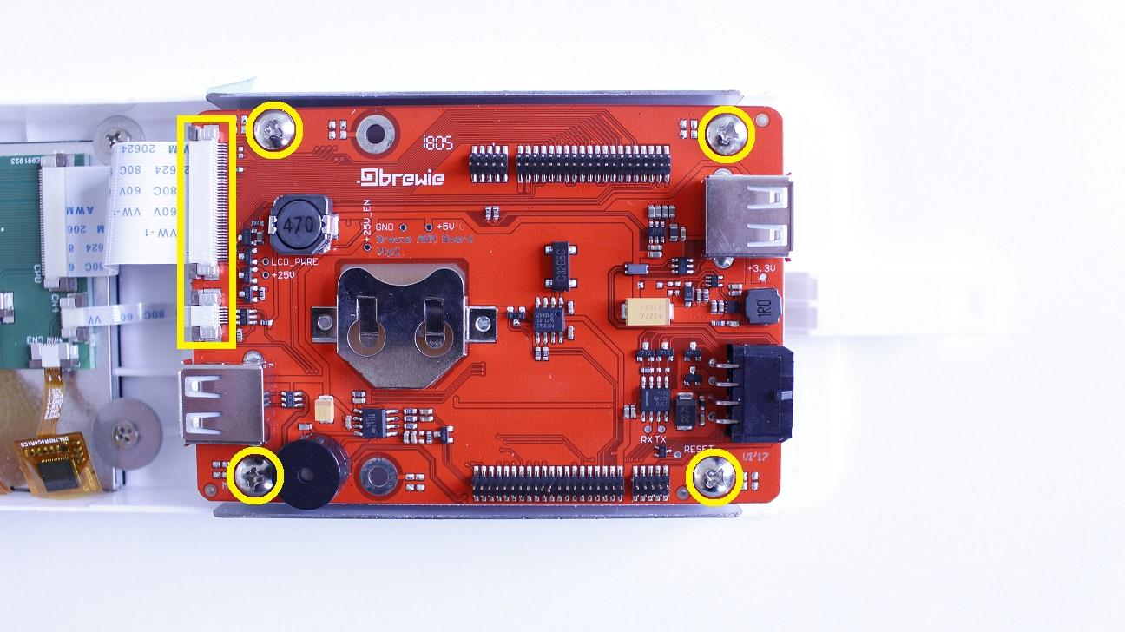

The ARM module can be removed now.

Reassemble consists of the same steps in reverse.